Computer Science 260
Homework 5: Geometric Shapes using AWT

Due: Fri. Mar. 29, at the beginning of class.

Write the code for a class that implements the Icon interface. Call your class GridSquaresIcon. The class should take a single constructor:

/** Create a new object that contains the given number of rows
and columns of squares of a given diameter.
@param nRows the number of rows of squares
@param nCols the number of columns of squares
@param diameter the diameter of each square
@param background the background color of the Icon
@param foreground the color of each circle
*/
public GridSquaresIcon (int nRows, int nCols,
int diameter, Color background, Color foreground)

You should assume that all integer parameters a positive integers. Check these conditions with asserts.

When paintIcon() is called, it should create an image with the following properties:

- The background image should be a rectangle large enough to hold a grid of nRows by nCols circles, each of the given diameter. The rectangle should have the color specified by the background parameter. Draw the rectangle first so that it is not drawn over the circles.
- The foreground image should be a grid of circles, each of which has the specified diameter. The color or each circle is given by the foreground parameter.

For example, if someone creates a StackedSquaresIcon object with the following constructor

StackedSquaresIcon i = new StackedSquaresIcon (
2, 3, 100, Color.Red, Color.BLUE);

then paintIcon() should draw this when called:

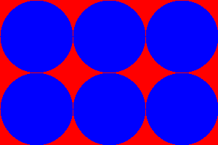

What to turn in: You will probably want to develop this on the computer. Don't, however, turn in any test code - turn in only the source code for your GridSquaresIcon class only. Don't forget comments and JavaDoc.

